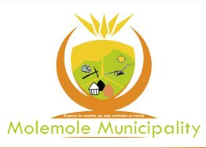

INVITATION TO BID

Date Published: 12 November 2018

Molemole Local Municipality hereby invites prospective service provider to submit bids for the following:
Project Number | Bid Description | CIDB/Minimum requirement | Compulsory Briefing Session | Evaluation Criteria | Closing Date and Time | Contact Person for Technical Enquiries
MLM/LED&P/02/2018/19 | Demarcation of 150 sites at Ratsaka village | N/A | N/A | 80/20 preference point system 80 Points Functionality.  60 points minimum qualifying score for evaluation on 80/20 | 26 November 2018 @ 11:00 | Mashotja F  @015 501 2365

IMPORTANT:
Bid documents are downloadable from e-tender as from the 15th November 2018 and completed Bids must be submitted in an enclosed envelop, bearing: THE NAME OF THE BIDDER, BID NUMBER and DESCRIPTION OF THE BID to Mogwadi Old Building, No 303 Church Street, Mogwadi, 0715 between 8:00 and 16:30, Mondays to Fridays.

The municipality is not bound to accept the lowest bid and reserves the right to accept any bid either wholly or part thereof. All SCM related enquiries can be directed to Ms. Ralephenya T.D on 015 501 2315 during office hours.

Mr. Mosena M.L
Municipal Manager

